**Class:** Final Year (Computer Science and Engineering)

**Year:** 2021-22 **Semester:** 1

**Course:** High Performance Computing Lab

**Practical No. 1**

**Exam Seat No: 2018BTECS00028**

1. Exam Seat Number – Akash Dilip Kamble

**Problem Statement 1: Print number of threads and prn**

**Screenshot 1:**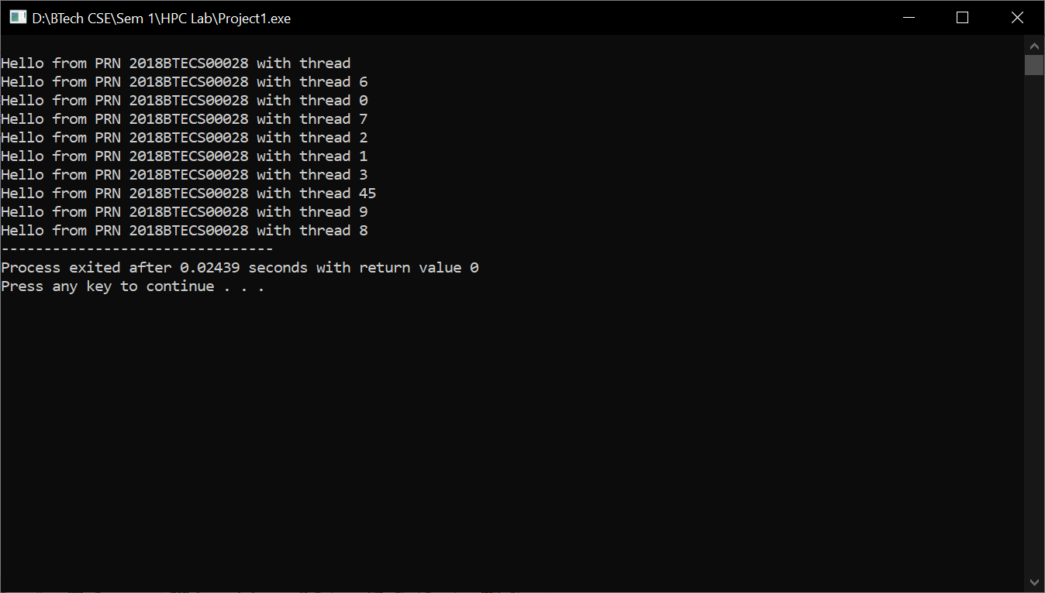

**Information :**

**Using OpenMp printed prn and thread id.**

**Github Link:**